**Undone Lifeboat Activity Template**

**Part 1: Roles**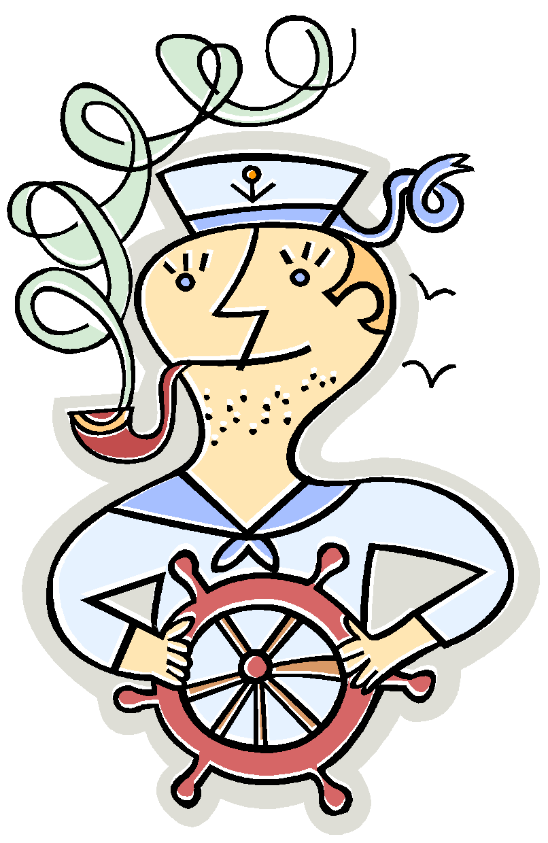

1. **Able-Bodied Sailor Jones**~ It is somewhat questionable how I was able to get from my assigned position below the deck to the life boat when no other sailor assigned to the lower decks managed to escape from the ship. I am in excellent health, not married, and I have no close relatives. 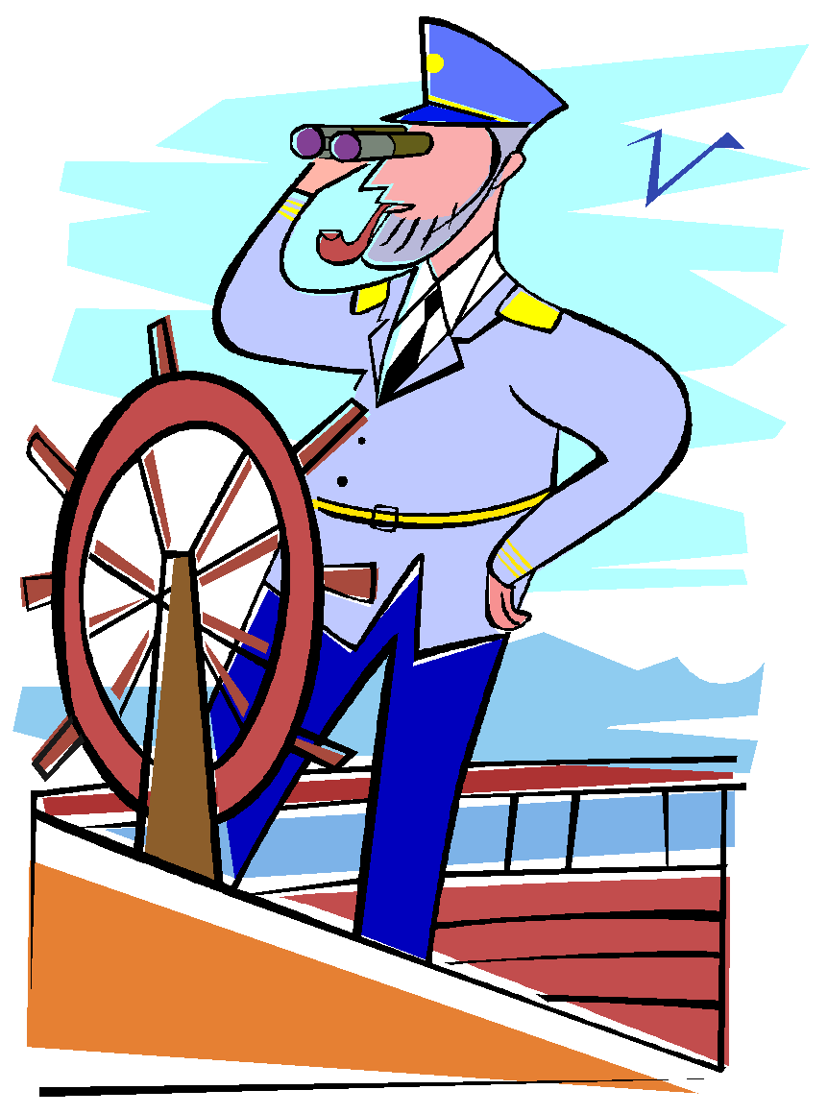

2. **Ship’s Officer O’Maley**~ I was the only high ranking officer aboard the ship that was able to get to the lifeboat. It is the boat that I have been assigned to in all of the emergency practice drills. I am a capable officer, have navigational skills, and am well-liked by passengers and crew members aboard the ship. In addition, I am in excellent health.



3. **Quarter Master MacDonald**~ Little is known about me. I did serve in the regular navy. During the explosion of the ship, I suffered injuries to both hands and cannot use either hand. I am married and have four children.



4. **Self-Made Millionaire Douglas**~ I own and manage one of the U.S.’s largest garment industrial complexes, which employs hundreds of factory workers. I am in good/excellent health, but I am overweight due to lack of exercise. 

5. **College Student Parsons**~ I am a college student who has been on a limited budged European vacation. I am a grand mal epileptic, and while abandoning the ship I had to leave all my medication behind. I am 22 years old and single. 

6. **Literature Nobel Prize Winner, Dr. Lightfoot**~ I am black and questions have been raised whether the Nobel Prize was awarded to me due to my race or my ability to write. I am 49 years old and in good health. I am married with two daughters who have families of their own. 

7. **Physics Nobel Prize Winner, Dr. Singleton**~ It has been said that I am about to release information to the world that will essentially bring about the solution to the world’s ecological problem. I am 62 years old and in excellent health. I was born and raised as part of a very wealthy family who lived in a small town in Arkansas. I am currently single. 

8. **Football Player, Mr. Small**~ I am a black man in my late twenties. I was a star football player at Ohio State University. I am currently a running back for a semi-pro football team in New York. I am happily married to Mrs. Small, who is also aboard the ship.



9. **Cheerleader, Mrs. Small**~ I am a white female in my late twenties. I was a cheerleader at Ohio State University, where I was also the Homecoming Queen. I am happily married to my college sweetheart, Mr. Small, and I am 8.5 months pregnant. 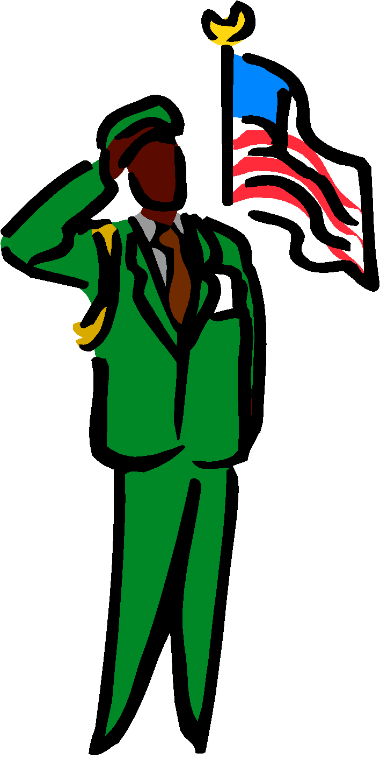

10. **Army Captain Thomas**~ I was recently decorated for my bravery and valor above and beyond the call of duty. I am on my way to the U.S. to personally receive the Medal of Honor from the President. While engaged in action, I lost my right leg. Aside from this condition, I am in good health. I am in my mid-thirties, married, and have 2 children. 

11. **Draft Evader Samuels**~ I left the United States two years ago in order to avoid the military draft. I then spent two years in Sweden, from which I was recently deported for dealing illegal drugs. I am in my early twenties, single, and in good health.



12. **Peace Corps Volunteer Davidson**~ I am a Peace Corps volunteer who has recently completed two years of work in India. I have a Master’s Degree in Engineering and am on my way back to Boston where I will be married in two months. I am 27 and in excellent health.

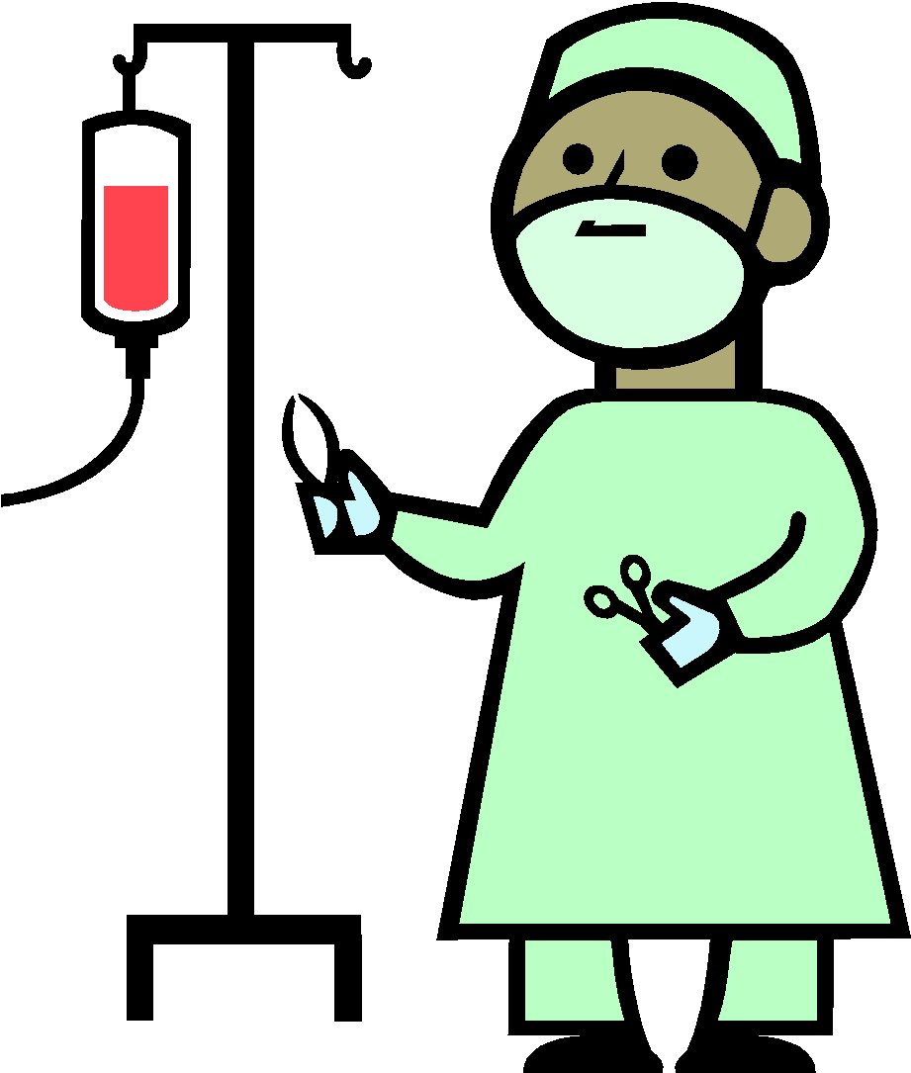

13. **Med Student Ryan**~ I am in my last year of medical school and I had been vacationing in France. I am 26 years old, single, and in excellent health.



14. **Elderly Man, Mr. Eldrige**~ I am traveling with my wife, Mrs. Eldridge. I am in my late 60s and on my way back to New Jersey after a one month vacation in Spain. I am suffering severely from arthritis and am not capable of walking without the aid of a cane. Next week, my wife and I will celebrate our 50th wedding anniversary. Together we have 8 children and 29 grandchildren who are all living in New Jersey.

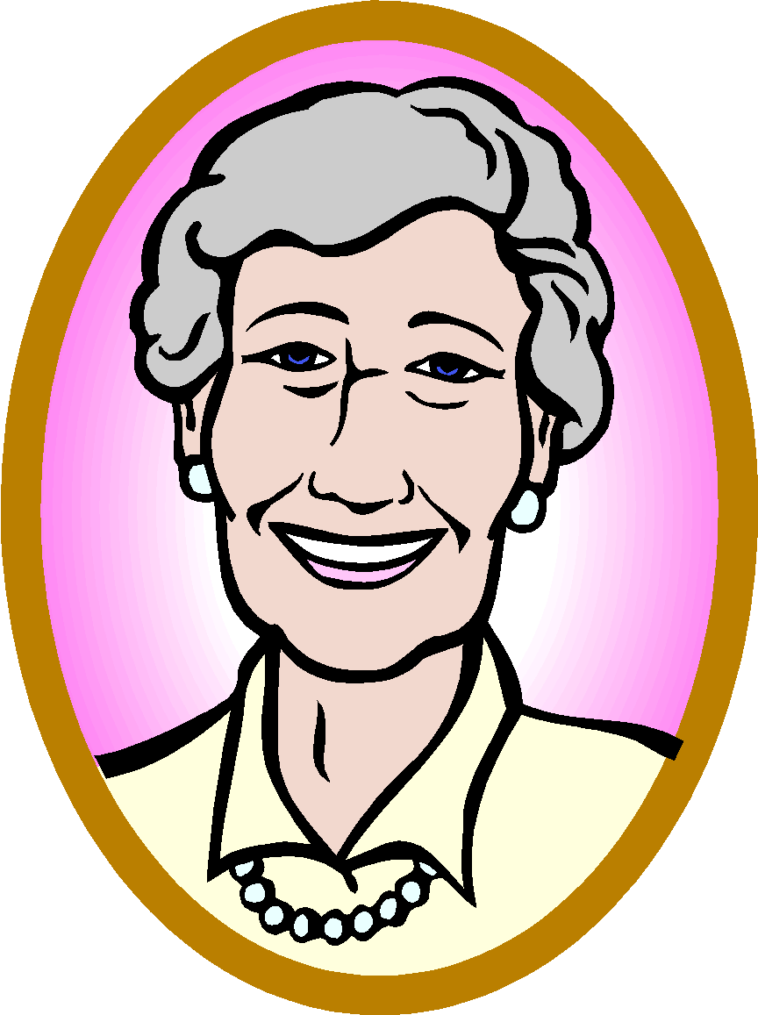

15. **Elderly Woman, Mrs. Eldrige**~ I am traveling with my husband, Mr. Eldridge. I am in my late 60s and on my way back to New Jersey after a one month vacation in Spain. Next week, my husband and I will celebrate our 50th wedding anniversary. Together we have 8 children and 29 grandchildren who are all living in New Jersey.



16. **Traveling Poet Carpenter**~ I am a 30 year old traveling poet in excellent health. I have never had a permanent home since I ran away from a New York orphanage 15 years ago. I spent 4 years in the Navy where I acquired a taste for sailing. I have since made several solo sailing voyages in the Caribbean. I have been divorced three times and I am currently separated from my 4th spouse who resides in Paris.

**Part Two: Story of the Undone**

In the short story “Undone” society faces a major problem. Esential resources such as food, water, and minerals used to make

|  |  |  |  |
| --- | --- | --- | --- |
| 1. **Able-Bodied Sailor Jones** | 2. **Ship’s Officer O’Maley** | 3. **Quarter Master MacDonald** | 4. **Self-Made Millionaire Douglas** |
| 5. **College Student Parsons** | 6. **Literature Nobel Prize Winner, Dr. Lightfoot** | 7. **Physics Nobel Prize Winner, Dr. Singleton** | 8. **Football Player, Mr. Small** |
| 9. **Cheerleader, Mrs. Small** | 10. **Army Captain Thomas** | 11. **Draft Evader Samuels** | 12. **Peace Corps Volunteer Davidson** |
| 13. **Med Student Ryan** | 14. **Elderly Man, Mr. Eldrige** | 15. **Elderly Woman, Mrs. Eldrige** | 16. **Traveling Poet Carpenter** |

**Part Three:**  Working in groups of three, decide who should stay (9 passengers) and who should go (7 passengers). *Briefly give your reasoning for saving/rejecting each person*.

Save / Reject 1. **Able-Bodied Sailor Jones:** 



Save / Reject 2. **Ship’s Officer O’Maley:**



Save / Reject 3. **Quarter Master MacDonald:**



Save / Reject 4. **Self-Made Millionaire Douglas:**

Save / Reject5. **College Student Parsons:**



Save / Reject6. **Literature Nobel Prize Winner, Dr. Lightfoot:**



Save / Reject7. **Physics Nobel Prize Winner, Dr. Singleton:**



Save / Reject8. **Football Player, Mr. Small:**



Save / Reject9. **Cheerleader, Mrs. Small:**



Save / Reject10. **Army Captain Thomas:**



Save / Reject 11. **Draft Evader Samuels:**

Save / Reject12. **Peace Corps Volunteer Davidson:**



Save / Reject13. **Med Student Ryan:**



Save / Reject14. **Elderly Man, Mr. Eldrige:**



Save / Reject15. **Elderly Woman, Mrs. Eldrige:**



Save/Reject16. **Traveling Poet Carpenter:**

**Part Four:** Journal Entry. After the activity in class, answer the following questions.

1. How did your group make the life/death decisions for the passengers on the ship (what process did you go through for each passenger)?
2. What key factors/status/values helped you to make your decisions?
3. Which passenger was the *easiest* to throw overboard? Why?
4. Which passenger was the most *difficult* to throw overboard? Why?
5. After the final classroom discussion, how many passengers that your group decided to keep onboard the lifeboat were saved? What do you think the reason for this similarity/difference was?
6. The fact that none of the decisions to throw a man/woman overboard happened for no reason at all shows us what about ourselves?